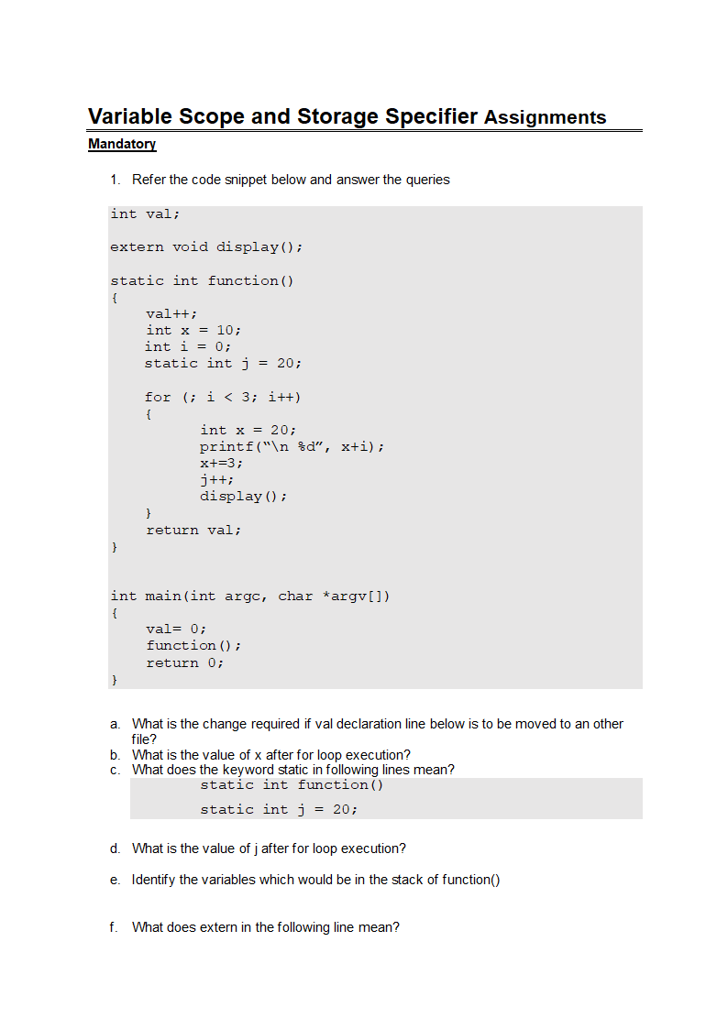

1. **What is the change required if val declaration line below is to be moved to an other file?**

**ANS:** If the val is declared in another function we need to use extern key word in this file. For **eg**: extern int val;

1. **What is the value of x after for loop execution?**

**ANS:** The original x declared in the function() function is 10, and it was never modified within the loop (because the x inside the loop shadows it).

So the value of x after the loop execution is 10.

**c. What does the keyword static in following lines mean?**

static int function()

static int j = 20;

**ANS:**

**static int function()**:  
The static keyword here means that the function, function() has **internal linkage**. This means that the function can only be called within the file in which it is defined and cannot be accessed from other files, even if they include the file with this definition. Essentially, the function is **private** to the current source file.

**static int j = 20;**  
The static keyword here means that the variable j retains its value between function calls. The variable j is **initialized only once** and its lifetime lasts for the duration of the program. Even though it's inside a function (in this case, function()), it will **persist across function calls** and will not be reinitialized on subsequent calls.

**d.What is the value of j after for loop execution?**

**ANS:** j is declared as static int j = 20;, meaning it retains its value across multiple calls to function().

j is incremented by 1 during each iteration of the for loop, which runs 3 times.

So, starting from j = 20, after 3 iterations, j will be incremented 3 times, giving the final value of j as:

Value of j after the loop execution = 20 + 3 = 23.

**e. Identify the variables which would be in the stack of function()**

**ANS:** i and the inner loop x are local stack variables.

**f. What does extern in the following line mean?**

extern void display();

**ANS:** The extern keyword is used to tell the compiler that the actual implementation of display() will be linked from another file at compile/link time.